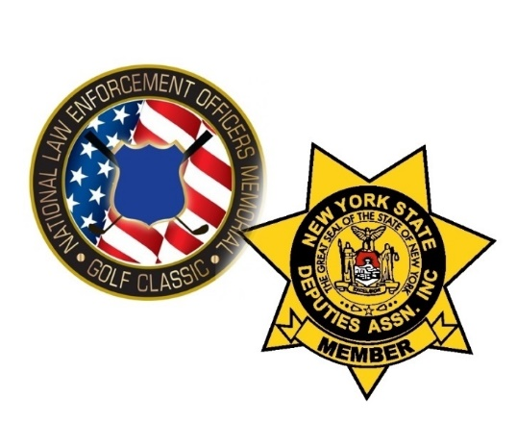

2023 NLEOMGC – NYSDA GOLF CLASSIC

August 12, 2023 @ Terry Hills Golf Course in Batavia NY
Name: Company:
Address: City:
State: Zip: Phone:
Email:

Golfer:
1. 2.
3. 4.
SPONSORSHIP PACKAGES:
DEPUTY ($600) includes foursome and one tee sign ☐
TEE/GREEN SIGN SPONSOR ($125) ☐ CART SPONSOR ($225) ☐
GOLF REGISTRATION ONLY:
FOURSOME ($520)☐ SINGLE GOLFER ($130) ☐
EARLY BIRD (BEFORE 6/30/22) ☐ FOURSOME ($460) ☐ SINGLE GOLFER ($115) ☐
Enclosed is payment in full for $
Please make checks payable to: NLEOMGC

Payments mailed to: NLEOMGC
25 Amenity Drive
Brockport, NY 14420

Any Questions feel free to contact:
Norman Itjen @ (585) 409-4540 email- Litjen@rochester.rr.com
Dan Morphet @ (585) 391-3961 email- nleomgc@aol.com

